

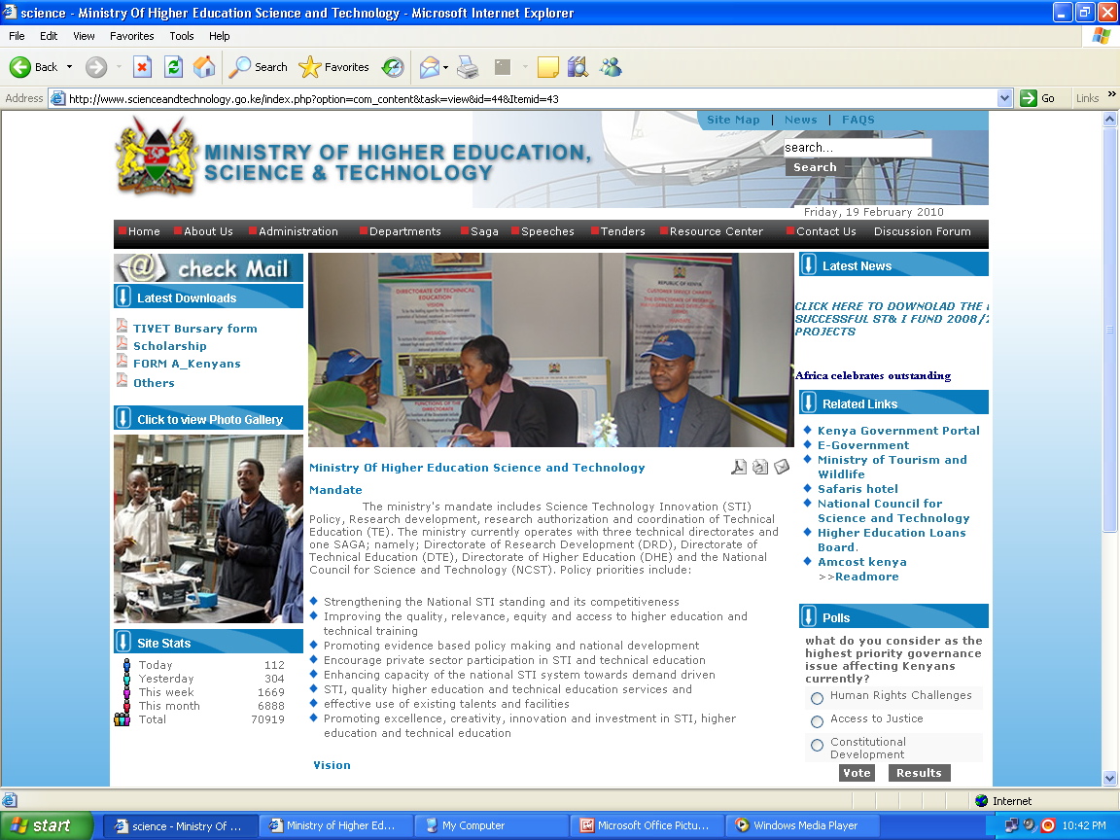
47
NKABUNE TECHNICAL TRAINING INSTITUTE
MINISTRY OF EDUCATION

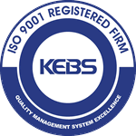

ADVERTISEMENT FOR COURSES

COURSE | DURATION | INTAKE |  | ENTRY GRADE | EXAMBODY
HOSPITALITY & INSTITUTIONAL MANAGEMENT
Diploma in Fashion Design & Clothing Technology | 3 Years | May/Sept |  | C-(minus) and above | KNEC
Diploma in Catering and Accommodation Management | 3 Years | May/Sept |  | C-(minus) and above | KNEC
Diploma in Food and Beverage Production, Sale and Service | 3years | May/Sept |  | C-(minus) and above | KNEC
Craft Certificate in Fashion design and Garment Making | 2 Years | May/Sept |  | D (plain) and above | KNEC
Craft Certificate in Catering and Accommodation Operations | 2 Years | May/Sept |  | D (plain) and above | KNEC
Craft In Food & Beverage Production and Service | 2 Years | May/Sept |  | D (plain) and above | KNEC
Artisan in Garment Making | 1 Year | May/Sept |  | D-(Minus) | KNEC
Artisan in Food and Beverage | 1 Year | May/Sept |  | D-(Minus) | KNEC
Diploma in Hairdressing Level 6 | 3 years | May/Sept |  | C-(minus) and above | CDACC
Diploma in Beauty Therapy Level 6 | 3 years | May/Sept |  | C-(minus) and above | CDACC
Hair Dressing and Beauty Therapy Level I | 1 Year | May/Sept |  | KCSE/KCPE | KNEC
Hairdressing | GRADE III | May/Sept |  | KCSE/KCPE | NITA
Beauty | GRADE III | May/Sept |  | KCSE/KCPE | NITA
Tailoring | GRADE III | May/Sept |  | KCSE/KCPE | NITA
Dressmaking | GRADE III |  | May/Sept | KCSE/KCPE | NITA
ENGINEERING DEPARTMENTS
Diploma in Electrical & Electronics Engineering (Power ) | 3 Years | May/Sept |  | C-(minus) and above | KNEC
Diploma in Mechanical Engineering ( Plant Option) | 3 Years | May/Sept |  | C-(minus) and above | KNEC
Diploma in Automotive Engineering | 3 Years | May/Sept |  | C-(minus) and above | KNEC
Diploma in Building Technology | 3 Years | May/Sept |  | C-(minus) and above | KNEC
Diploma In Civil Engineering | 3 Years | May/Sept |  | C-(minus) and above | KNEC
Craft Certificate in Land Survey | 3 Years | May/Sept |  | C-(minus) and above | KNEC
Craft certificate in Electrical & Electronics Engineering (Power) | 2 Years | May/Sept |  | D (plain) and above | KNEC
Craft Certificate in Building Technology | 2 Years | May/Sept |  | D (plain) and above | KNEC
Craft certificate Automotive Engineering | 2 Years | May/Sept |  | D (plain) and above | KNEC
Craft certificate In Plumbing | 2 Years | May/Sept |  | D (plain) and above | KNEC
Craft certificate Welding and Fabrication | 2 Years | May/Sept |  | D (plain) and above | KNEC
Artisan In Plumbing | 1 Year | May/Sept |  | KCSE/KCPE | KNEC
Craft in Masonry | 2 Years | May/Sept |  | Masonry Grade 1 | KNEC
Artisan In Electrical & Electronic Engineering | 1 Year | May/Sept |  | KCSE/KCPE | KNEC
Artisan In Motor Vehicle Mechanics | 1 Year | May/Sept |  | KCSE/KCPE | KNEC
Artisan In Masonry | 1 Year | May/Sept |  | KCSE/KCPE | KNEC
Motor Vehicle Mechanics | GRADE III | May/Sept |  | OPEN | NITA
Welding & Fabrication | GRADE III | May/Sept |  | OPEN | NITA
Driving School | 1 Month | Open |  | Open | NTSA
COMPUTING & INFORMATICS DEPARTMENT
Diploma in Information Communication Technology - Module I | 3 Years | May/Sept |  | C-(minus) and above | KNEC
Craft Certificate in Information Technology - Module I | 2 Years | May/Sept |  | D plain and above | KNEC
Computer Packages | 3Months | May/Sept |  | KCSE Certificate | NTTI
Web Development | 3Months | May/Sept |  | KCSE | NTTI
BUSINESS STUDIES & ENTREPRENEURSHIP DEPARTMENT
Diploma in Secretarial Studies Module I | 3Years | May/Sept |  | C-(minus) and above | KNEC
Diploma in Supply Chain Management Module I | 3 Years | May/Sept |  | C-(minus) and above | KNEC
Diploma in Business Management - Module I | 3 Years | May/Sept |  | C-(minus) and above | KNEC
Diploma in Cooperative Management -Module I | 3 Years | May/Sept |  | C-(minus) and above | KNEC
Diploma in Project Management – Module I | 3 Years | May/Sept |  | C-(minus) and above | KNEC
Craft Certificate in Cooperative Management – Module I | 2 Years | May/Sept |  | D plain and above | KNEC
Craft Certificate in Project Management– Module I | 2 Years | May/Sept |  | D plain and above | KNEC
Craft Certificate in Secretarial Studies Stages | 2 Years | May/Sept |  | D plain and above | KNEC
Craft Certificate in Business Management –Module I | 2Years | May/Sept |  | D plain and above | KNEC
Certificate in Supply Chain Management –Module I | 2 Years | May/Sept |  | D plain and above | KNEC
Accounting Technician Diploma - ATD | 2Years | May/Sept |  | C-(minus) and above | KASNEB
Certificate in Accounting and Management Skills- CAMS | 1 ½Year | May/Sept |  | D plain and above | KASNEB
LIBERAL STUDIES DEPARTMENT
Diploma in Social Work and Community Development | 3 Years | May/Sept |  | C-(minus) and above | KNEC
Craft Certificate in Social Work and Community Development | 2 Years | May/Sept |  | D (plain) and above | KNEC

P.O. BOX 330-60200 MERU – KENYA TEL: 0719186814 E-mail: nkabunetti@yahoo.com, nttinkabune@gmail.com

For more information, please visit our website www.nkabunetti.ac.ke

Website: www.nkabunetti.ac.ke

Please write to: The Principal Nkabune T.T.I, enclosing Ksh.300 bankerscheque (Course Application Fee) and copies of KCSE
Result slip, Leaving Certificate, National ID, Birth Certificate and any other testimonials. Include your telephone contacts.
ISO 9001:2015 CERTIFIED

